PRICE OFFER

TABLE SAW
MODEL: SPEED FORMAT

KLIENT:
Názov spoločnosti:
Adresa:
IČ DPH:
Kontaktná osoba:
Mena ponuky: | Euro
Dátum ponuky: | 2022 / 2023

- BASIC DESCRIPTION OF THE MACHINE

Professional table saw for longitudinal cuts.
The machine is an ideal solution for all companies whose priority is the processing of solid wood. The machine has no tilt or precut. It offers a robust and stable construction with a large number of configurations.
Basic division of the machine:
Type | BASIC | TOP
Type of electric fence | Standard 5 memories | Programmable with touch screen
Extension tables | - | 1x central sliding  1x rear  1x table behind the cut
Laser | - | YES
Foot cut trigger | Button operation / Optional small foot switch | Full-length foot control

Version of the parallel fence:
- Basic, electrically adjustable with numerical positioning and memory containing 5 values
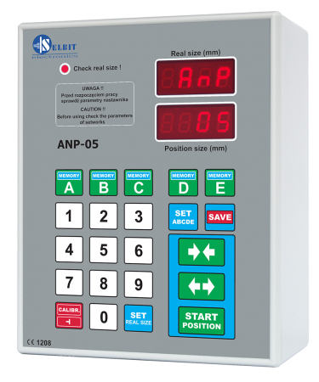
- Programmable fence - Control using a PLC and touch display.
- Extended fence with grippers for processing flat materials and glulam panels with the possibility of cutting into strips. Length 1000 - 3200mm

- TECHNICAL PARAMETERS OF THE MACHINE

Machine model | Speed Format 6200
Maximum saw blade diameter | ø 550 / 30 mm
Number of reel blade positions | 60 / 100 / 160 mm
Maximum cutting height with a 550mm disc | 160 mm
Tilting of the saw aggregate | NO
Speed of the main saw blade | 3500 rpm.
Main engine power | 5.5 / 7.5 / 11 kW
Cut with a standard parallel fence | 500 mm
Table size | 6200 × 1000 mm
Cut length | 6200 mm
Cutting speed | 5 – 30 m / min

- ADDITIONAL EQUIPMENT

Additional equipment
Additional ruler stopper | 45 euro / pc
Central cross table + fence ( moveable ) | 2500 euro
End cross table + fence ( static ) | 1500 euro
Extending the cut with a parallel fence | + 500 mm = + 750 euro
Excentric pressure on ruller | 150 euro
Laser for marking the cut | 500 euro
Rear table extension for cross-cutting long materials | 1050 euro
Digital cross fence with one stopper | 1 000 euro
Extended fence with pneumatic gripper + PLC control and touch screen display | L2000= 10 000 euro
Programming fence with touch screen display | 5 000 euro
Main engine power 11kW | 800 euro
Small foot switch | 700 euro
Full-length foot control | 2000 euro
Individual changes to the machine are possible by agreement

- PRICE OFFER AND PAYMENT TERMS:

Offer
Machine | SPEED FORMAT 4200 7.5kW / BASIC
Validity of the offer: | 30 Days
Delivery date | 8-12 Weeks
Terms of payment: | 30% Before production / 70% before expedition
Warranty: | 12 months
Price offer: | 29 000 euro without VAT
Price for machine | 29 000 euro

Machine alternatives
SPEED FORMAT 3200 7,5kW / BASIC | 21 000 euro
SPEED FORMAT 4200 7,5kW / BASIC | 23 000 euro
SPEED FORMAT 5200 7,5kW / BASIC | 26 000 euro

BASIC configuration
Machine | SPEED FORMAT 6200 / 7.5kW / BAISC
Central cross table | -
Laser | -
Width of cut | 500 mm
Electric ruler ( „2“ ) | Memory with 5 values
Engine | 7.5
Rear table extension for cross-cutting long materials | -
SUMAR PRICE | 29 000

Machine alternatives
SPEED FORMAT 4200 7,5kW / TOP | 31 000 euro
SPEED FORMAT 6200 7,5kW / TOP | 38 000 euro
Suitable to the machine
SPS – 500
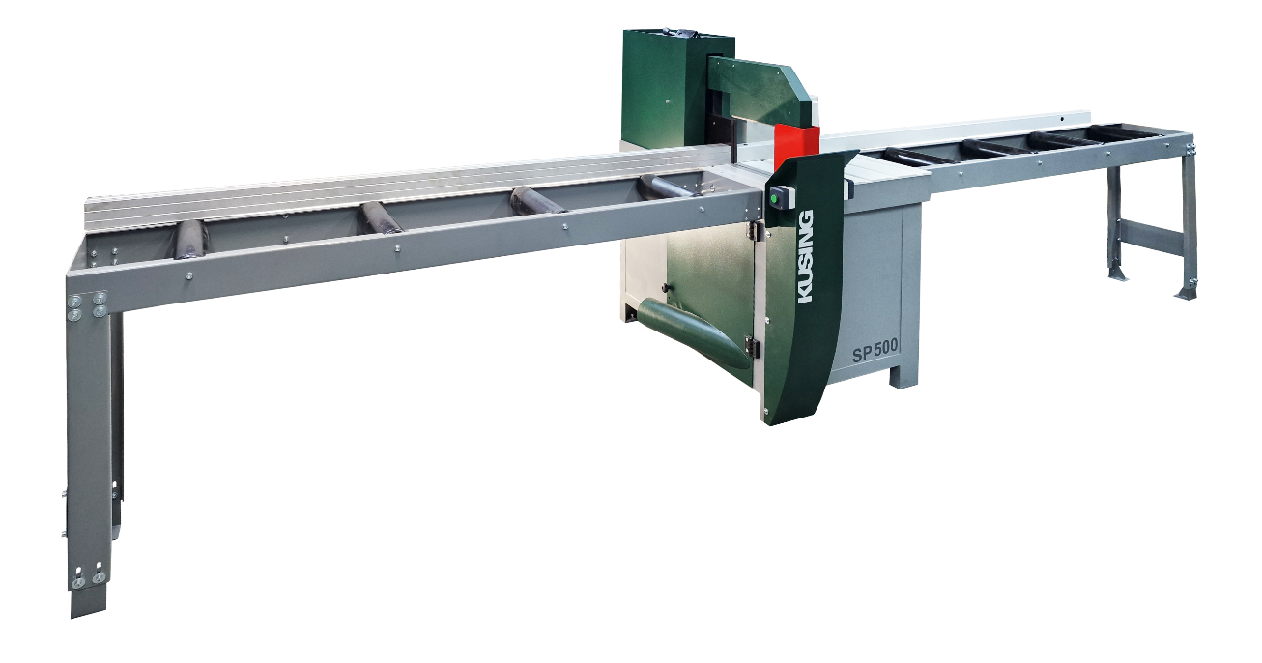
Machine description:
Fully electric bottom shortening saw KUSING SPS-500 with the power of the main motor 3, 4, 5.5kW.
Continuously adjusting the speed of the cutting cycle using a frequency converter from 2 to 6 s.
The machine is produced in two versions ("A" "B") when the position of the ruler relative to the axis of the disk changes, which makes it possible to adjust the parameters of the cross-section.
Cross-section of variant "A": 50 x 300 / 150 x 200
Section "B" variant: 50 x 350 / 120 x 300

Technical parameters:
Max. material width: 300 / 350 mm
Max. Material thickness: 150 mm
Shaft diameter: 30 mm
Saw blade diameter: 500 mm
Saw blade speed: 3500 rpm.
Engine power: 3 / 4 / 5.5 kW
Power motor: 0.55 kW.
Cutting cycle speed with FM: 2-6 s. / cycle.
Weight of the machine approx.: approx. 280 kg
Suction: 1 x 120 mm.
Machine dimensions: W / L: 1100 x 800 mm
Working height: 860 mm

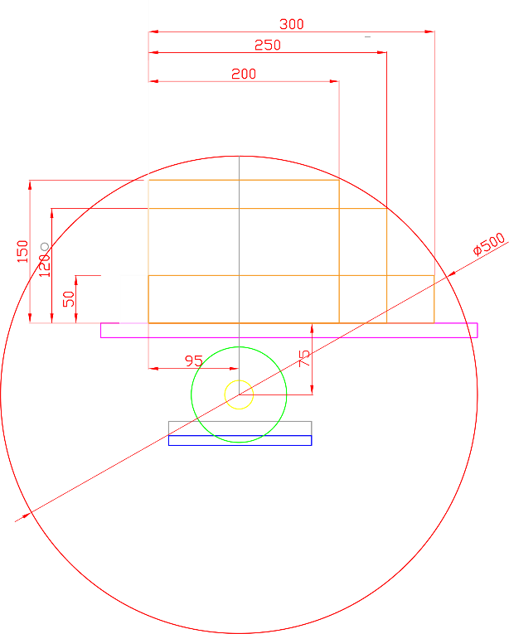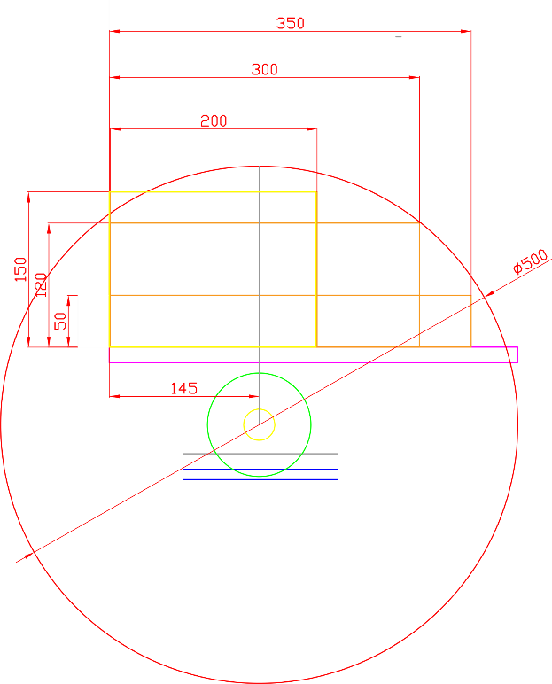
Variant „A“ Variant „B“

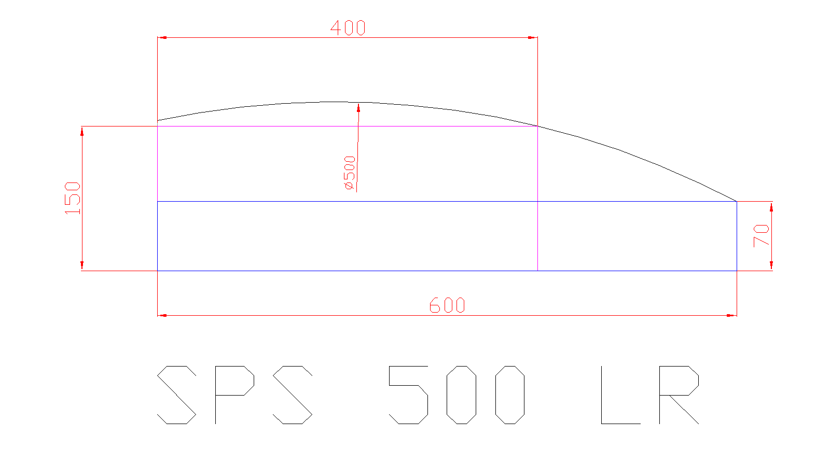

Rulers according to the request: price: 100 euro / m
Mechanical stopper on the ruler: 45 euro / pc
Penumatic stopper: 450 euro / pcs.

Option of controlled ruler according to specification

Roller tracks according to specification

4. CONCLUSION:

Dear business partners,

KUSING is a manufacturer of woodworking machines with a tradition dating back to 1991. It is a traditional manufacturer of woodworking machines with its own production technology.

With our products, you are not only buying a machine, but also the assurance that we will take care of your machine in full throughout the machine's lifetime, including all spare parts and later service.

Our service technicians are at your disposal 24/7, whether it is quick advice on the delivery of the machine.

Thank you for your interest in our services and the trust you have shown.

We wish you a nice day.

Sincerely, KUSING Collective.
For more information, call: Ján Kurila +421 948 330 442

